CSS BRITISH HISTORY · TOPIC 3 · KNOWLEDGE BASE
Pitt, the French Revolution, Napoleon and the Union with Ireland (1783–1815)
Pitt the Younger, the French Revolution and its influence on Britain, Burke and Paine, repression, the wars against Napoleon, the Irish rising of 1798 and the Union of 1801

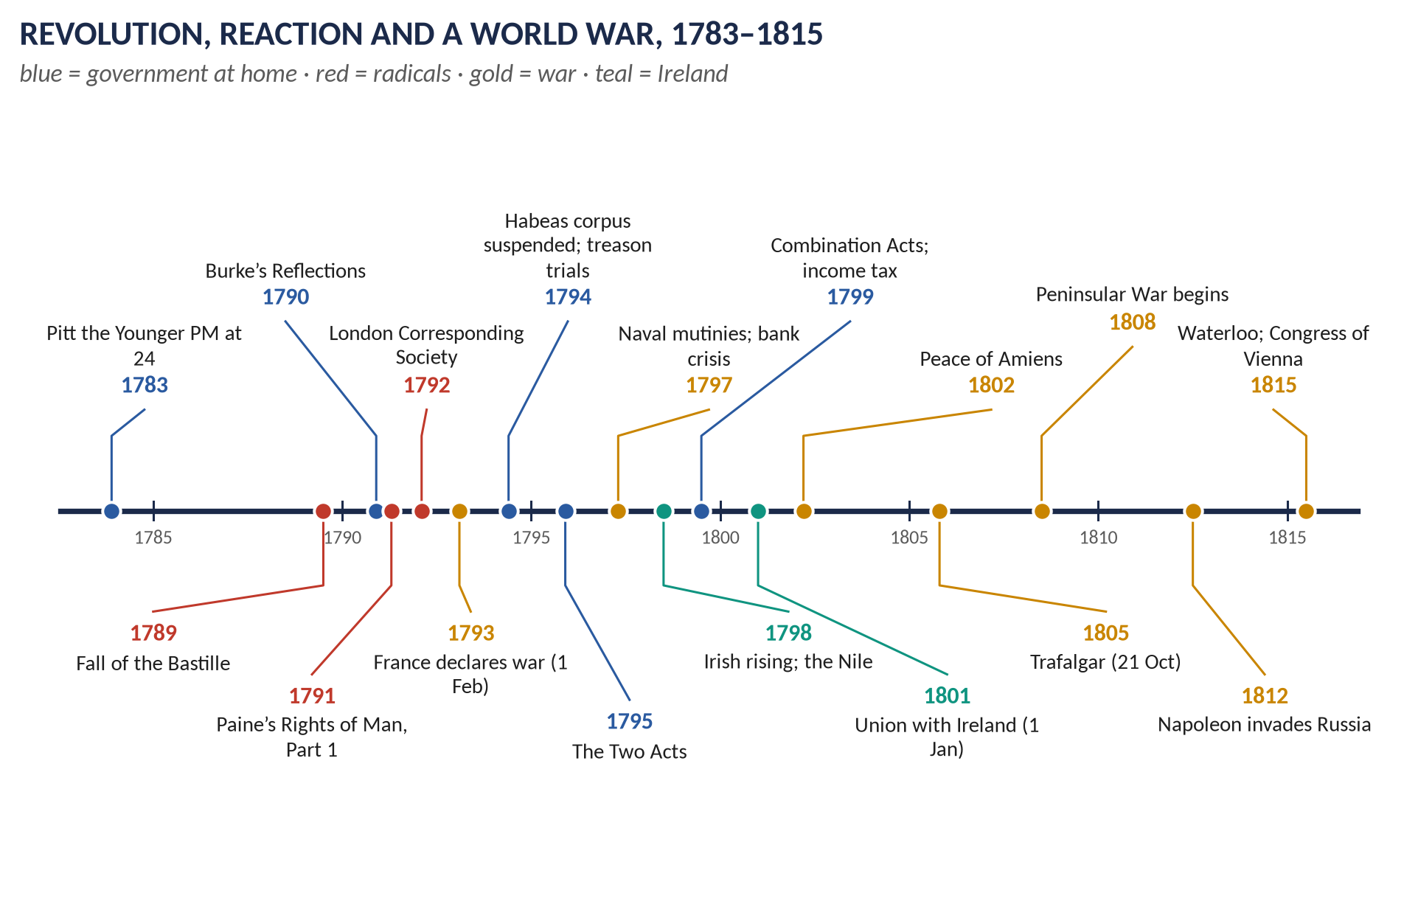
Syllabus heads IV and VI. Asked 6 times in 2015–2026 — the Revolution's influence on Britain five times (2020 and 2022 word for word) — plus 3 MCQs. Told as a story first, then five chapters, 100 one-liners and a stand-alone revision sheet.
Topic 3 of 10 · read with the companion document T3QA
Contents
HOW TO USE THIS · Updating the contents
Right-click the contents → Update Field → Update entire table, before saving as PDF.

How to Use This Document 4
What this Topic covers 4
The words this topic needs 4
Part One — The Story 6
1.1 Pitt rebuilds the state (1783–1792) 6
1.2 The Revolution and the great debate (1789–1792) 6
1.3 From fear to repression (1792–1801) 6
1.4 Ireland: rebellion and Union (1791–1801) 7
1.5 The war against Napoleon (1793–1815) 8
1.6 The cost and the legacy 9
Part Two — The Cast and the Time-line 10
2.1 The cast 10
2.2 The time-line 11
Part Three — The Chapters 12
Chapter 1 · Pitt the Younger, 1783–1801 13
1.1 How he came to power 13
1.2 The peacetime reformer (1784–92) 13
1.3 The war minister and the repressor (1793–1801) 13
Chapter 2 · The French Revolution and Britain 14
2.1 The causes of the Revolution (in brief) 14
2.2 British reactions — three phases 14
2.3 The influence on political thought 14
2.4 The influence on society 15
2.5 The government's measures — a list to learn 15
Chapter 3 · Britain and the Napoleonic Wars 17
3.1 Why Britain fought 17
3.2 Britain's strategy 17
3.3 The key actions 17
3.4 Why Britain won 17
3.5 The Congress of Vienna (1814–15) 18
3.6 The impact of the wars on Britain 18
Chapter 4 · The Union with Ireland, 1801 19
4.1 Ireland before the Union 19
4.2 The rising of 1798 19
4.3 Pitt's reasons for Union 19
4.4 The terms 19
4.5 The controversies 20
4.6 The consequences 20
Part Four — Historians and Quotations 21
Part Five — The Examiner's Record 22
Part Six — The One-Liner Bank 23
One-liners · Pitt the Younger 23
One-liners · The Revolution and the debate 23
One-liners · Repression 24
One-liners · Ireland and the Union 25
One-liners · The wars against France and Napoleon 25
One-liners · The impact on Britain 26
Part Seven — Revision Sheet · Topic 3: Pitt, the French Revolution, Napoleon and the Union with Ireland, 1783–1815 28
R3.1 The story in eight lines 28
R3.2 The influence of the Revolution on political thought 28
R3.3 The influence on society 29
R3.4 The measures to check the Revolution 29
R3.5 "Panic" and the after-effects 29
R3.6 The Union of 1801 29
R3.7 Britain and the Napoleonic Wars 29
R3.8 Dates to write in every answer 30

How to Use This Document

What this Topic covers
Topic 3 covers 1783 to 1815: Pitt the Younger, the French Revolution and its influence on Britain, the great debate between Burke and Paine, the government's repression of radicals, the Revolutionary and Napoleonic Wars, the Irish rising of 1798 and the Act of Union of 1801. Syllabus Head IV (Union of England and Ireland) and Head VI (the French Revolution and Napoleonic Wars: causes, Britain and the wars, impact on Britain).
WHAT THE EXAMINER HAS ASKED · Why this topic matters
One family dominates: the French Revolution's influence on Britain — 2016, 2020, 2022, 2023 and a 2025 short note. 2020 Q3 and 2022 Q5 are identical. The Union of 1801 was set in 2025. Never set: Britain and the Napoleonic Wars — the fighting itself — although it is a named sub-head.

THE STORY IN SIMPLE WORDS · The story so far — where Topic 2 left us
In 1783 Britain had lost thirteen American colonies. Lord North had fallen; the King had defeated the Fox–North coalition; and in December 1783 George III made William Pitt the Younger, aged twenty-four, prime minister. The debt stood at about £240 million, Ireland had won its own Parliament (1782), and the old Whig world had broken up into factions.

The words this topic needs
Word | Meaning
Jacobin | A member of the radical club that dominated the French Revolution in 1793–94; in Britain, a term of abuse for any radical.
Radical | A reformer who wanted root-and-branch change — usually manhood suffrage and annual parliaments.
Corresponding society | A reform club that exchanged letters with others across the country; the London Corresponding Society (1792) was the most famous.
Loyalism | Organised support for King, Church and constitution — associations, songs, "Church and King" mobs.
Habeas corpus | The right not to be imprisoned without trial. Its "suspension" allowed detention without charge.
Sedition | Words or writings meant to stir up hatred of the government or constitution.
Combination | A trade union or workers' association; banned by the Combination Acts (1799–1800).
United Irishmen | The Irish society (1791) of Protestants and Catholics that sought reform, then independence with French help.
Coalition | An alliance of European powers against France — there were seven between 1793 and 1815.
Continental System | Napoleon's blockade of British trade with Europe (from 1806).
Orders in Council | Britain's counter-blockade of Napoleon's Europe (1807).
Concert of Europe | The system of great-power conferences created at Vienna (1815).

Part One — The Story

1.1 Pitt rebuilds the state (1783–1792)
William Pitt the Younger, son of Chatham, became prime minister in December 1783 at twenty-four — "a kingdom trusted to a schoolboy's care", mocked his enemies. He won a large majority in the 1784 election and set about repairing the damage of the American war. He cut smuggling by lowering duties, created a new sinking fund (1786) to pay off debt, reorganised customs, and signed the Eden Treaty (1786), a free-trade agreement with France. The India Act (1784) put the East India Company under a Board of Control. His one attempt at parliamentary reform (1785) failed.

1.2 The Revolution and the great debate (1789–1792)
On 14 July 1789 a Paris crowd stormed the Bastille. Many Britons were delighted: Charles James Fox called it "how much the greatest event that ever happened in the world", and the young Wordsworth wrote, "Bliss was it in that dawn to be alive". The Dissenting minister Richard Price preached that Britain should follow France.
Edmund Burke replied with Reflections on the Revolution in France (November 1790): society was a partnership of the dead, the living and the unborn; rights came from inherited tradition; and the Revolution would end in bloodshed and tyranny. Thomas Paine answered with Rights of Man (1791–92): every generation had the right to govern itself, hereditary monarchy was absurd, and the poor should have pensions and schooling paid for by taxes on the rich. It sold perhaps 200,000 copies. Mary Wollstonecraft added A Vindication of the Rights of Woman (1792).
Reformers organised. The London Corresponding Society, founded in January 1792 by the shoemaker Thomas Hardy, charged a penny a week and demanded manhood suffrage and annual parliaments. Loyalists organised too: in 1791 a "Church and King" mob in Birmingham burned the house and laboratory of the scientist and Dissenter Joseph Priestley.

1.3 From fear to repression (1792–1801)
In 1792 the Revolution turned violent — the September Massacres, the abolition of the monarchy — and on 21 January 1793 Louis XVI was guillotined. On 1 February 1793 France declared war on Britain. Fear of a British revolution became the governing fact of politics.
- A Royal Proclamation against seditious writings (May 1792); Paine was tried in his absence and outlawed.
- John Reeves's loyalist associations (November 1792) spread across the country.
- In Scotland, Thomas Muir and Thomas Palmer were sentenced to transportation (1793).
- Habeas corpus was suspended in May 1794; Hardy, Horne Tooke and Thelwall were tried for high treason — and acquitted by London juries.
- After a mob attacked the King's coach, the Two Acts (1795) widened the law of treason and banned meetings of more than fifty people without a magistrate's permission.
- The Combination Acts (1799–1800) outlawed trade unions; the Unlawful Societies Act (1799) banned the LCS.
The Whig party split in 1794 when the Duke of Portland and the conservative Whigs joined Pitt; Fox and a small group opposed the war and the repression. Reform was postponed for a generation.
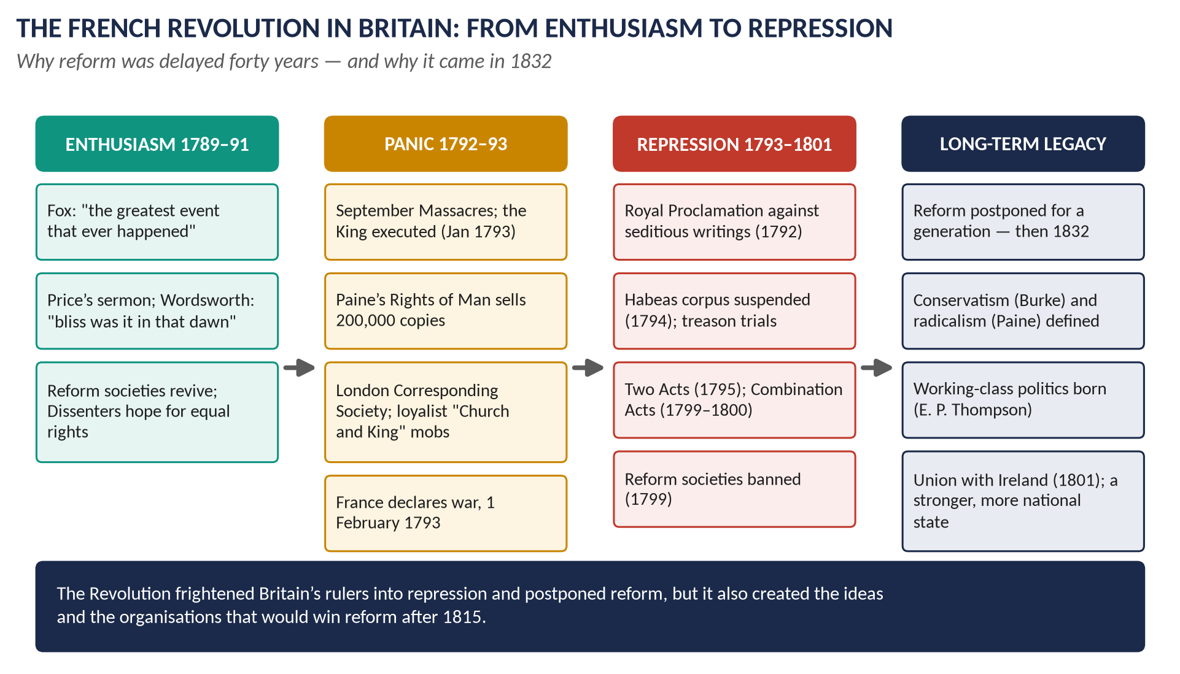
Figure 1 · The French Revolution in Britain: from enthusiasm to panic, repression and long-term legacy.

1.4 Ireland: rebellion and Union (1791–1801)
In Ireland the Revolution's ideas met old grievances. The United Irishmen (1791), led by the Protestant lawyer Theobald Wolfe Tone, united Catholics and Presbyterians in a demand first for reform and then for an independent republic. A French fleet reached Bantry Bay in December 1796 but storms prevented a landing. In May–June 1798 risings broke out in Leinster, Antrim and Down; the rebels were crushed at Vinegar Hill. A small French force landed at Killala in August and surrendered at Ballinamuck. Perhaps 30,000 people died. Tone was captured and died in prison.
Pitt concluded that Ireland could only be secured by abolishing its Parliament. After one defeat (1799), the Irish Parliament voted itself out of existence in 1800, persuaded by peerages, places and payments managed by Castlereagh and Cornwallis. The Act of Union took effect on 1 January 1801: the United Kingdom of Great Britain and Ireland, with 100 Irish MPs at Westminster. Pitt had hinted that Catholic Emancipation would follow; George III refused, and Pitt resigned (February 1801).
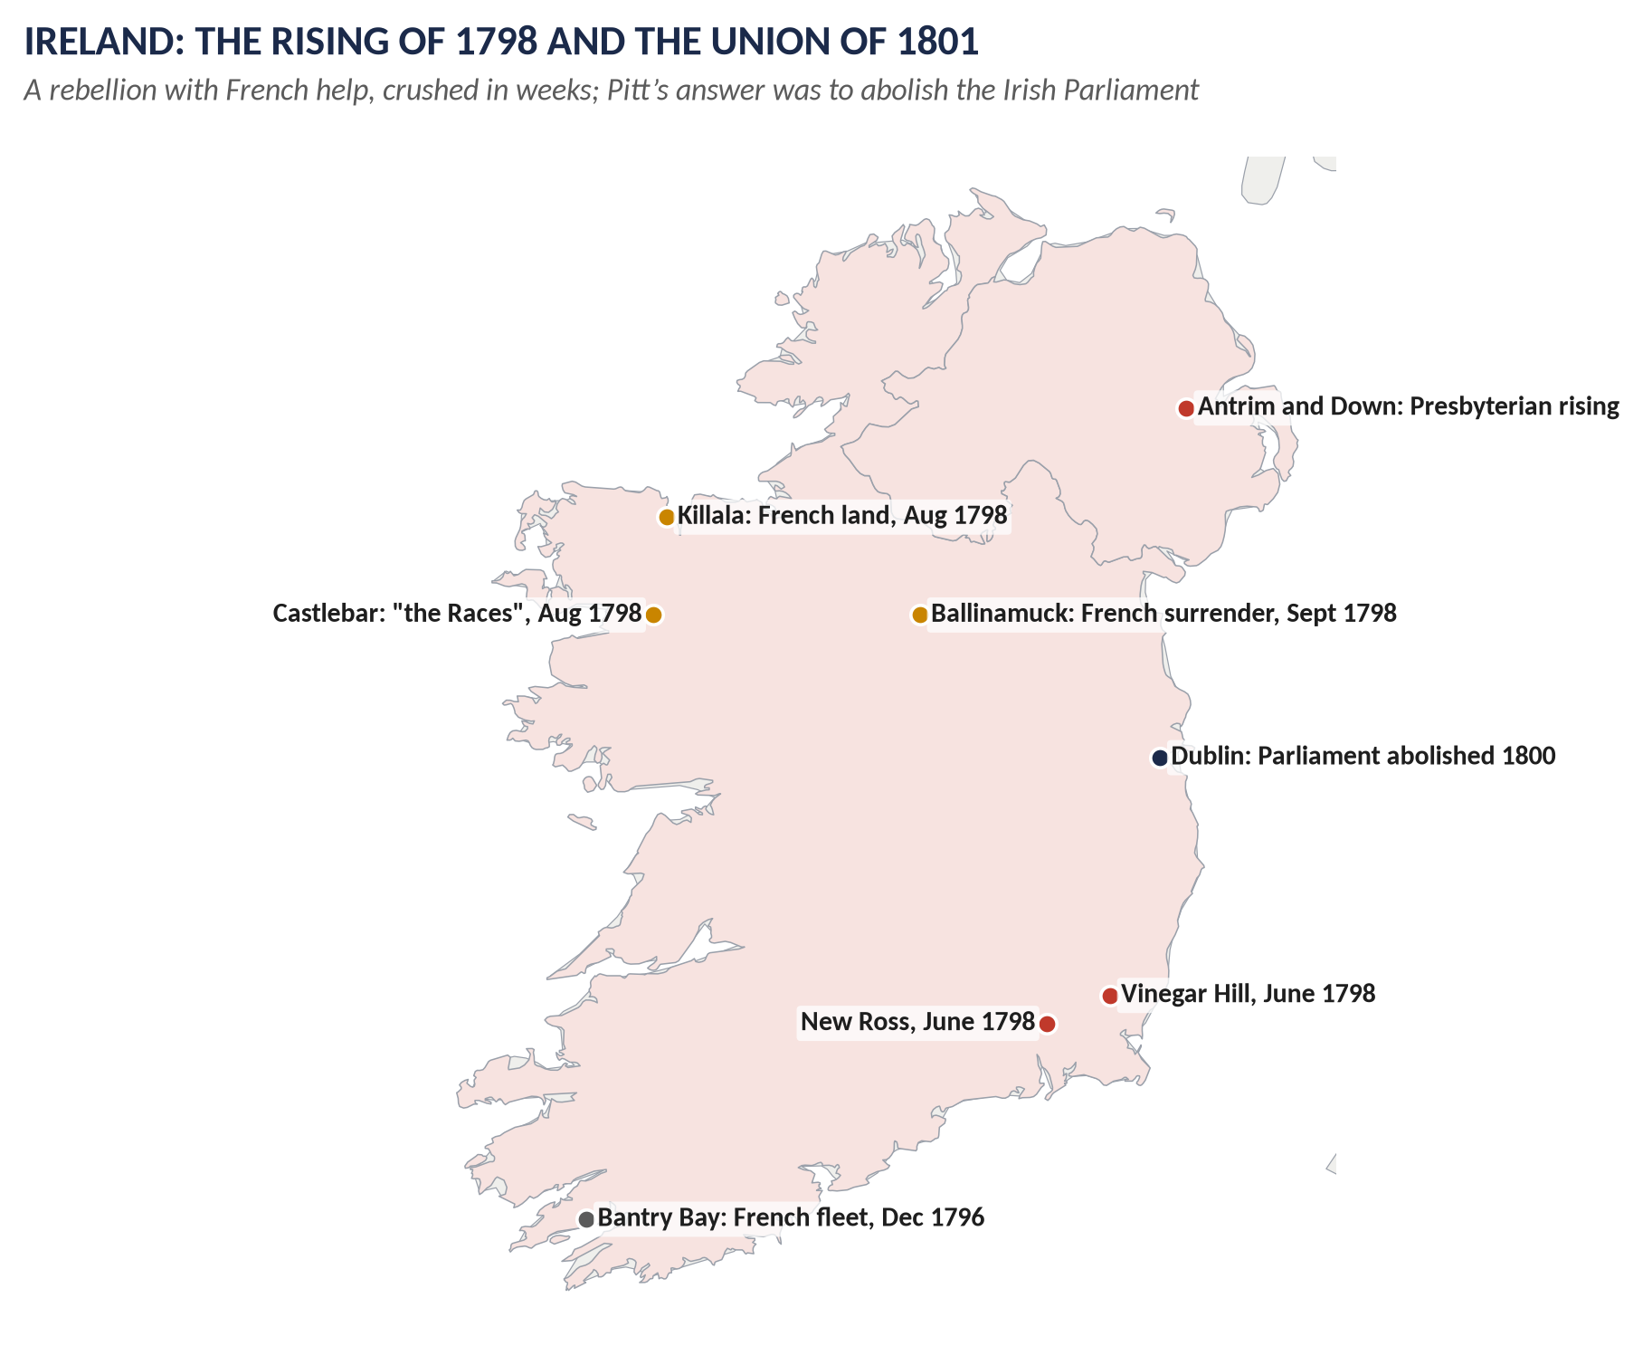
Figure 2 · The 1798 rising, the French landings, and the Dublin Parliament that the Union abolished.

1.5 The war against Napoleon (1793–1815)
Britain fought France almost continuously for twenty-two years. It was the richest power but had a small army, so its strategy was always the same: command the sea, pay allies on the continent, and strike where the navy could reach.
The navy did its part: Glorious First of June (1794), Cape St Vincent and Camperdown (1797), Nelson's destruction of the French fleet at the Nile (1798), and Copenhagen (1801). The Peace of Amiens (1802) lasted a year. From 1803 Napoleon massed an army at Boulogne to invade England; Nelson's victory at Trafalgar on 21 October 1805 ended that threat for ever, though Nelson died in the battle. Pitt, back in office from 1804, died in January 1806, exhausted.
On land Napoleon was unbeatable for a decade — Austerlitz (1805), Jena (1806), Friedland (1807). He tried to strangle Britain economically with the Continental System (1806), and Britain replied with the Orders in Council (1807). The breakthrough came in Spain and Portugal: from 1808 Sir Arthur Wellesley, later the Duke of Wellington, fought the Peninsular War, holding the lines of Torres Vedras (1810) and winning at Salamanca (1812) and Vitoria (1813). Napoleon's invasion of Russia (1812) destroyed his Grand Army; the allies beat him at Leipzig (1813) and he abdicated in April 1814. He escaped from Elba, and on 18 June 1815 Wellington and the Prussian Blücher defeated him at Waterloo.
At the Congress of Vienna (1814–15) Castlereagh helped build a balance of power to contain France. Britain took no European land but kept strategic bases: Malta, the Cape Colony, Ceylon, Mauritius, Heligoland, Trinidad and a protectorate over the Ionian Islands.
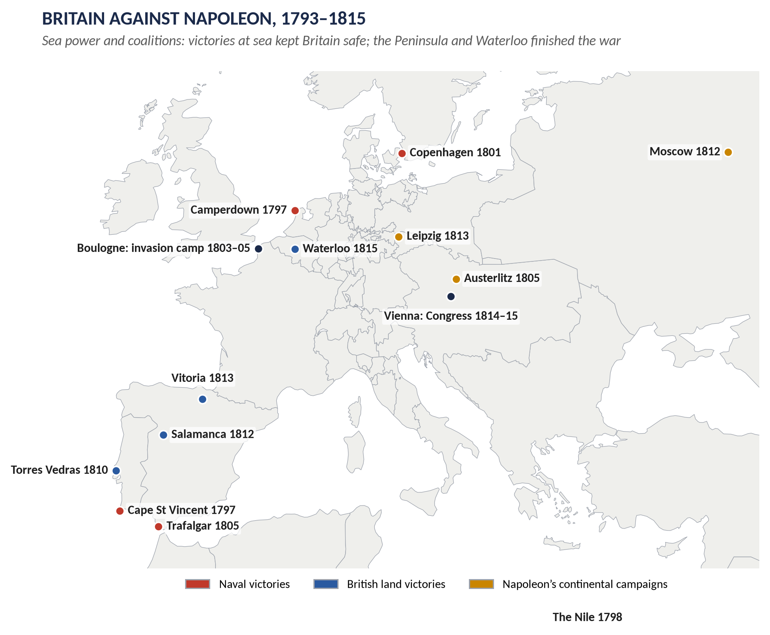
Figure 3 · Britain against Napoleon: the naval victories, the Peninsula and Waterloo.

1.6 The cost and the legacy
The war cost about £1,000 million. The National Debt rose from roughly £240 million to about £745 million. Pitt introduced income tax in 1799 (2s in the pound on incomes over £200). The navy and army employed half a million men. Victory made Britain the unchallenged world power of the nineteenth century — but it left a country of high taxes, unemployment and radical discontent, which exploded in the years after 1815 (Topic 5).
VERDICT · The story in one sentence
The French Revolution split British opinion, frightened its rulers into a generation of repression and postponed reform; the wars that followed drove Britain to abolish the Irish Parliament and to spend a thousand million pounds — and left it, in 1815, the greatest power in the world.

Part Two — The Cast and the Time-line

2.1 The cast
Person | Dates | Who they were — in one line
William Pitt the Younger | 1759–1806; PM 1783–1801, 1804–06 | Rebuilt the finances, led the war and repression, made the Union with Ireland.
Charles James Fox | 1749–1806 | Whig leader; welcomed the Revolution; opposed the war and the repression.
Edmund Burke | 1729–97 | Whig who wrote Reflections (1790) — the founding text of conservatism.
Thomas Paine | 1737–1809 | Author of Rights of Man (1791–92); outlawed in Britain.
Mary Wollstonecraft | 1759–97 | Wrote A Vindication of the Rights of Woman (1792).
Richard Price | 1723–91 | Dissenting minister whose sermon of 1789 provoked Burke.
Thomas Hardy | 1752–1832 | Shoemaker; founder of the London Corresponding Society; acquitted of treason in 1794.
Duke of Portland | 1738–1809 | Led the conservative Whigs into coalition with Pitt (1794).
Theobald Wolfe Tone | 1763–98 | Founder of the United Irishmen; sought French help.
Lord Castlereagh | 1769–1822 | Carried the Irish Union; Foreign Secretary at Vienna.
Horatio Nelson | 1758–1805 | Victor of the Nile, Copenhagen and Trafalgar; killed at Trafalgar.
Duke of Wellington | 1769–1852 | Won the Peninsular War and Waterloo.
Napoleon Bonaparte | 1769–1821 | Emperor of the French 1804–14, 1815.

2.2 The time-line
Figure 4 · Revolution, reaction and a world war, 1783–1815.

Part Three — The Chapters

Chapter 1 · Pitt the Younger, 1783–1801

1.1 How he came to power
- December 1783: George III dismissed the Fox–North coalition over Fox's India Bill and appointed Pitt, aged 24.
- 1784 election: Pitt won a large majority with royal patronage and genuine public support.

1.2 The peacetime reformer (1784–92)
Policy | What it did
Finance | New sinking fund (1786); consolidated customs duties; lower duties to defeat smuggling (tea duty cut from 119% to 12.5%)
Trade | Eden Treaty (1786) with France — freer trade, influenced by Adam Smith
India | India Act (1784): a government Board of Control over the East India Company
Canada | Constitutional Act (1791): Upper and Lower Canada with elected assemblies
Reform | Proposed to abolish 36 rotten boroughs (1785) — defeated; he did not try again
Slave trade | Supported Wilberforce's motions personally, but never made abolition government policy

1.3 The war minister and the repressor (1793–1801)
Pitt was a better peace minister than war minister: his early strategy of colonial expeditions and continental subsidies failed to stop French expansion. At home he became the author of "Pitt's Terror" — the repressive laws of 1792–1801 (Chapter 2). He introduced income tax (1799), carried the Union with Ireland (1800), and resigned in 1801 when the King refused Catholic Emancipation. He returned in 1804 and died in January 1806.
VERDICT · Pitt in one line
A brilliant financial reformer before 1793, a determined but not brilliant war leader after it, and the man who tied Ireland to Britain — his reputation as the founder of modern Toryism was made by others after his death.

Chapter 2 · The French Revolution and Britain

2.1 The causes of the Revolution (in brief)
1. Bankruptcy: France's debt, swollen by the American war, forced Louis XVI to call the Estates-General (May 1789).
2. Privilege: nobles and clergy were largely exempt from taxes; the Third Estate bore the burden.
3. Enlightenment ideas: Rousseau's popular sovereignty; the example of America.
4. Hunger: the harvest of 1788 failed and bread prices peaked in July 1789.

2.2 British reactions — three phases
Phase | What happened
Welcome, 1789–91 | Fox, Price, the Dissenters and the young Romantics saw France following Britain's 1688; reform societies revived
Division and fear, 1791–93 | Burke v Paine; the LCS; the Priestley riots; the September Massacres; the King's execution; war (1 Feb 1793)
Repression and war, 1793–1801 | Proclamation, loyalist associations, treason trials, habeas corpus suspended, Two Acts, Combination Acts, LCS banned

2.3 The influence on political thought
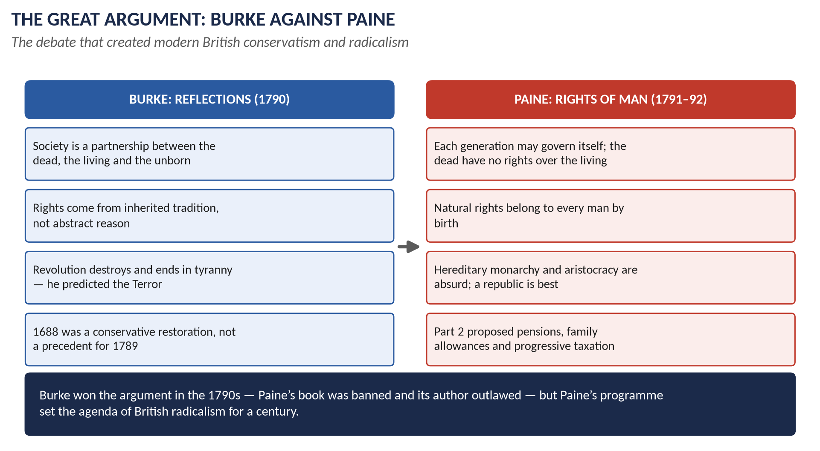
Figure 5 · Burke against Paine: the argument that shaped British conservatism and radicalism.
- Burke founded modern conservatism: society as an organic inheritance; change by gradual reform, not revolution.
- Paine gave British radicalism its programme: natural rights, manhood suffrage, a republic, welfare paid by progressive taxes.
- Wollstonecraft (1792) extended rights to women; William Godwin's Political Justice (1793) pushed reason towards anarchism.
- Party: the Whigs split (1794); the Tories became the party of order; the word "Jacobin" discredited reform for thirty years.
- Long run: the language of rights re-emerged in the reform agitation after 1815 and in Chartism (Topic 4).

2.4 The influence on society
- Popular politics: artisans organised for the first time in national societies — for E. P. Thompson the moment the English working class began to "make itself".
- Loyalism: far larger than radicalism — hundreds of associations, "Church and King" crowds, volunteer corps of over 400,000 men by 1804.
- Religion: the evangelical revival grew; the ruling class embraced religion as a barrier to revolution.
- Culture: Wordsworth, Coleridge and Southey moved from enthusiasm to conservatism.
- War economy: income tax, high prices, food riots (1795, 1800), the naval mutinies at Spithead and the Nore (1797), and the Bank of England's suspension of cash payments (1797).
- National identity: Linda Colley argues that the long war with France forged a stronger sense of being British.

2.5 The government's measures — a list to learn
Year | Measure | Aim
1792 | Royal Proclamation against seditious writings | Stop the circulation of Paine
1792 | Reeves's loyalist associations | Mobilise loyal opinion; report radicals
1793 | Scottish sedition trials (Muir, Palmer) | Exemplary punishment
1793 | Aliens Act | Watch French émigrés and agents
1794 | Habeas corpus suspended | Detain radicals without trial
1794 | Treason trials of Hardy, Horne Tooke, Thelwall | Destroy the LCS leadership (failed: acquitted)
1795 | Two Acts: Treasonable Practices; Seditious Meetings | Widen treason; ban large meetings
1797 | Newspaper Act; mutineers executed | Control the press and the forces
1799 | Unlawful Societies Act | Ban the LCS and United Irishmen
1799–1800 | Combination Acts | Ban trade unions
1800–01 | Act of Union | Close the Irish "back door"

WHAT THE EXAMINER HAS ASKED · Where Chapter 2 has been asked
2016 Q2 (measures to check the influence) · 2020 Q3 = 2022 Q5 (influence on English society and political thought) · 2023 Q3 (the "panic" and the after-effects) · 2025 Q8(a) short note (impact on economy and society). All answered in T3QA.

Chapter 3 · Britain and the Napoleonic Wars

3.1 Why Britain fought
- Security: French occupation of the Low Countries — the coast opposite England — and the opening of the Scheldt (1792).
- The balance of power: France under the Republic and then Napoleon dominated Europe.
- Trade and empire: French policy threatened British commerce and colonies.
- Ideology: after 1793, a war against revolution.

3.2 Britain's strategy
1. Sea power: blockade, protect trade, seize enemy colonies.
2. Subsidies: gold to Austria, Prussia and Russia — seven coalitions.
3. Peripheral land war: small expeditions, then the Peninsula.
4. Economic war: the Orders in Council against the Continental System.

3.3 The key actions
Year | Action | Significance
1794 | Glorious First of June | First great naval victory of the war
1797 | Cape St Vincent; Camperdown | Spanish and Dutch fleets defeated
1798 | The Nile | Nelson destroys the French fleet; Napoleon stranded in Egypt
1801 | Copenhagen | Danish fleet neutralised
1802 | Peace of Amiens | A one-year truce
1805 | Trafalgar (21 Oct) | Franco-Spanish fleet destroyed; invasion impossible; Nelson killed
1806–07 | Continental System; Orders in Council | Economic war
1808–14 | Peninsular War | Torres Vedras (1810), Salamanca (1812), Vitoria (1813) — the "Spanish ulcer"
1812 | Invasion of Russia | Napoleon's Grand Army destroyed
1813 | Leipzig | The Battle of the Nations
1815 | Waterloo (18 June) | Wellington and Blücher end the Hundred Days

3.4 Why Britain won
1. Naval supremacy — Trafalgar made Britain invulnerable.
2. Money — the income tax, the Bank and the National Debt paid for its own forces and its allies'.
3. Industry — the Industrial Revolution supplied arms and exports.
4. Allies — Russia, Austria and Prussia provided the armies.
5. Wellington — and the Spanish resistance.
6. Napoleon's mistakes — Spain and Russia.

3.5 The Congress of Vienna (1814–15)
- Castlereagh's aims: contain France, restore a balance of power, and keep Britain free of continental commitments.
- Results: a strengthened Netherlands (with Belgium) and Prussia on the Rhine; Austria dominant in Italy; the Bourbons restored in France; the Concert of Europe.
- Britain's gains: Malta, the Cape Colony, Ceylon, Mauritius, Heligoland, Trinidad, Tobago, St Lucia, and the Ionian Islands.

3.6 The impact of the wars on Britain
Area | Impact
Finance | War cost about £1,000 million; debt rose to about £745 million; income tax 1799–1816
Economy | Industrial growth (iron, cotton); high food prices; the Corn Law of 1815 to protect farmers
Society | Unemployment after demobilisation of some 300,000 men; Luddism (1811–16)
Politics | Tory dominance (1807–30); repression continued — Spa Fields (1816), Peterloo and the Six Acts (1819)
World role | The only global power; naval supremacy for a century; the "Pax Britannica"

TRAP — DO NOT FALL INTO IT · The blind spot
"Britain and the Napoleonic Wars" is a named sub-head that has never been set as a full question. Be ready to answer "How did Britain defeat Napoleon?" or "Assess the impact of the Napoleonic Wars on Britain."

Chapter 4 · The Union with Ireland, 1801

4.1 Ireland before the Union
- A Protestant Ascendancy ruled a Catholic majority (about three-quarters of the population) through the Penal Laws.
- Grattan's Parliament (1782): the Irish Parliament won legislative independence during the American war — but it remained Protestant and managed from Dublin Castle.
- Catholic Relief Acts of 1792–93 gave Catholics the vote, but not seats in Parliament.
- The United Irishmen (1791) under Wolfe Tone, inspired by France, sought first reform and then a republic.

4.2 The rising of 1798
- A French fleet reached Bantry Bay (1796) but could not land.
- Martial law and brutal disarming in Ulster (1797).
- Rising: Leinster, Wexford (Vinegar Hill, 21 June), Antrim and Down; sectarian killing on both sides.
- The French: General Humbert landed at Killala (August), won at Castlebar, surrendered at Ballinamuck.
- Toll: perhaps 30,000 dead.

4.3 Pitt's reasons for Union
1. Security: close the "back door" to France in wartime.
2. Control: Grattan's Parliament had shown it could disagree with London (for example on the Regency Crisis of 1788–89).
3. Religion: inside a Protestant United Kingdom, Catholics could be emancipated without endangering Protestant rule.
4. Economics: free trade with Britain would bring Ireland prosperity.

4.4 The terms
- The United Kingdom of Great Britain and Ireland from 1 January 1801.
- 100 Irish MPs at Westminster; 28 Irish peers and 4 bishops in the Lords.
- The Churches of England and Ireland united as one Protestant established church.
- Free trade (with some temporary duties); separate Irish exchequer until 1817.

4.5 The controversies
- Corruption: after the Irish Commons rejected Union in 1799, Castlereagh and Cornwallis won it in 1800 with peerages, places and compensation of about £1.25 million to the owners of abolished boroughs.
- Protestant opposition: Grattan and the Orange lodges resisted the loss of "their" Parliament.
- Catholic hope and betrayal: many Catholic bishops supported Union on the understanding that Emancipation would follow; George III refused (his coronation oath), and Pitt resigned (1801). Emancipation came only in 1829 — extracted by O'Connell.

4.6 The consequences
- Irish nationalism changed character: from a Protestant patriot movement to a Catholic national movement — Emmet (1803), O'Connell's Repeal campaign (1840s), Young Ireland (1848), the Fenians (1858), Home Rule (1870s–1914), independence (1922).
- The Famine (1845–49) under the Union poisoned relations for ever.
- Instability for the UK: the Irish Question broke Peel's party (1846) and Gladstone's (1886); Irish MPs decided who governed in 1885–86 and 1910.
WHAT THE EXAMINER HAS ASKED · Where Chapter 4 has been asked
2025 Q3: "Analyze the controversies surrounding the Act of Union 1801…" — answered in T3QA. MCQ 2026: the Act created the United Kingdom of Great Britain and Ireland.

Part Four — Historians and Quotations
Historian or source | The view to quote
Edmund Burke, Reflections (1790) | Society is "a partnership… between those who are living, those who are dead, and those who are to be born".
Thomas Paine, Rights of Man (1791) | "The vanity and presumption of governing beyond the grave is the most ridiculous and insolent of all tyrannies."
E. P. Thompson, The Making of the English Working Class (1963) | The 1790s were when the working class began to "make itself" — and "Pitt's Terror" drove it underground.
Linda Colley, Britons (1992) | The war with France forged a patriotic British identity across classes.
H. T. Dickinson | Loyalism was a mass movement, far larger than radicalism.
Eric Hobsbawm, The Age of Revolution (1962) | The "dual revolution" — French political and British industrial — made the modern world.

"How much the greatest event it is that ever happened in the world, and how much the best!" — Charles James Fox, on the fall of the Bastille, 1789
"Bliss was it in that dawn to be alive, / But to be young was very heaven!" — William Wordsworth, The Prelude
"England expects that every man will do his duty." — Nelson's signal at Trafalgar, 1805
"It has been a damned nice thing — the nearest run thing you ever saw in your life." — Wellington, on Waterloo

Part Five — The Examiner's Record
Paper | The question as set | Family | Type
2016 · Q2 · Section A | What measures were adopted by England to check the influence of the French Revolution of 1789 on England? | The French Revolution and Britain | Policy analysis
2020 · Q3 · Section A | Estimate the influence of the French Revolution on English society and political thought. | The French Revolution and Britain | Impact / significance
2022 · Q5 · Section A | Estimate the influence of the French Revolution on English society and political thought. | The French Revolution and Britain | Impact / significance
2023 · Q3 · Section A | 'The English people got so much frightened by the developments in France that there prevailed a sort of panic across the country.' Analyse the after-effects of the French Revolution on England. | The French Revolution and Britain | Quotation / claim
2025 · Q3 · Section A | Analyze the controversies surrounding the Act of Union 1801, focusing on the differing perspectives of Irish and British politicians. Assess its impact on Irish nationalism and the stability of the United Kingdom. | Union with Ireland, 1801 | How far / extent
2025 · Q8(a) · Section B | Short note: Impact of the French Revolution on the British economy and society | The French Revolution and Britain | Short note

Part Six — The One-Liner Bank
HOW TO USE THIS · How to use the one-liners
Cover the answer after the arrow. 100 questions; bold words are the ones examiners test. The past MCQs are solved in T3QA.

One-liners · Pitt the Younger
1. When did Pitt the Younger become prime minister, and at what age? → December 1783, aged 24.
2. Whose son was Pitt the Younger? → Pitt the Elder, Earl of Chatham.
3. Which coalition did George III dismiss to make Pitt PM? → The Fox–North coalition.
4. Which Act of 1784 set up a Board of Control over the East India Company? → The India Act.
5. Which fund did Pitt create in 1786 to pay off debt? → A new sinking fund.
6. Which 1786 trade treaty did Pitt sign with France? → The Eden Treaty.
7. By how much did Pitt cut the duty on tea? → From 119% to 12.5%.
8. What happened to Pitt's reform bill of 1785? → It was defeated; he never tried again.
9. Which Act of 1791 created Upper and Lower Canada? → The Constitutional Act.
10. When did Pitt introduce income tax? → 1799.
11. Why did Pitt resign in 1801? → George III refused Catholic Emancipation.
12. When did Pitt die? → January 1806.

One-liners · The Revolution and the debate
13. When did the Paris crowd storm the Bastille? → 14 July 1789.
14. Who called the Revolution "how much the greatest event… that ever happened in the world"? → Charles James Fox.
15. Which poet wrote "Bliss was it in that dawn to be alive"? → William Wordsworth.
16. Whose 1789 sermon provoked Burke? → Richard Price's.
17. When was Burke's Reflections on the Revolution in France published? → November 1790.
18. What did Burke call society? → A partnership between the dead, the living and the unborn.
19. Who wrote Rights of Man (1791–92)? → Thomas Paine.
20. Roughly how many copies of Rights of Man were sold? → About 200,000.
21. What did Part 2 of Rights of Man propose? → Pensions, family allowances and schooling funded by progressive taxes.
22. Who wrote A Vindication of the Rights of Woman (1792)? → Mary Wollstonecraft.
23. Who wrote Political Justice (1793)? → William Godwin.
24. Which scientist's house was burned by a "Church and King" mob in 1791? → Joseph Priestley's (Birmingham).
25. When and by whom was the London Corresponding Society founded? → January 1792, by the shoemaker Thomas Hardy.
26. What were the LCS's two main demands? → Manhood suffrage and annual parliaments.
27. What was the LCS subscription? → A penny a week.
28. Which aristocratic Whig reform club was founded in 1792? → The Friends of the People (Charles Grey).
29. When was Louis XVI executed? → 21 January 1793.
30. When did France declare war on Britain? → 1 February 1793.
31. What did the 2026 MCQ ask about the Revolution and war? → "The French Revolution led to Britain…" — answer None of these: France declared war on Britain.
32. Which historian said the working class "made itself" in these years? → E. P. Thompson.
33. Which historian stressed loyalism as a mass movement? → H. T. Dickinson.

One-liners · Repression
34. What did the Royal Proclamation of May 1792 target? → Seditious writings — above all Paine.
35. What happened to Paine in Britain? → He was tried in his absence and outlawed (1792).
36. Who founded the loyalist associations (November 1792)? → John Reeves.
37. Which Scottish reformers were transported in 1793? → Thomas Muir and Thomas Palmer.
38. When was habeas corpus suspended? → May 1794.
39. Who were tried for high treason in 1794? → Thomas Hardy, John Horne Tooke and John Thelwall.
40. What was the verdict? → Acquitted by London juries.
41. What were the Two Acts of 1795? → The Treasonable Practices Act and the Seditious Meetings Act.
42. What event provoked the Two Acts? → An attack on the King's coach (October 1795).
43. What did the Seditious Meetings Act ban? → Meetings of more than 50 people without a magistrate's permission.
44. Which Acts of 1799–1800 banned trade unions? → The Combination Acts.
45. When were the Combination Acts repealed? → 1824.
46. Which Act of 1799 banned the LCS? → The Unlawful Societies Act.
47. When did the Whig party split over the Revolution? → 1794 — Portland joined Pitt.
48. Who led the Foxite Whigs in opposition? → Charles James Fox.
49. What did Whigs call the repression? → "Pitt's Terror".
50. Where did the naval mutinies of 1797 take place? → Spithead and the Nore.
51. What did the Bank of England suspend in 1797? → Cash payments (paying notes in gold).

One-liners · Ireland and the Union
52. What was "Grattan's Parliament"? → The Irish Parliament after it won legislative independence in 1782.
53. When were the United Irishmen founded, and by whom? → 1791, by Theobald Wolfe Tone.
54. Where did a French fleet fail to land in December 1796? → Bantry Bay.
55. When was the great Irish rising? → May–June 1798.
56. Where were the Wexford rebels defeated? → Vinegar Hill (21 June 1798).
57. Where did the French land in August 1798? → Killala (County Mayo).
58. Where did the French surrender? → Ballinamuck.
59. Roughly how many died in 1798? → About 30,000.
60. Which two men carried the Union through the Irish Parliament? → Castlereagh and Cornwallis.
61. When did the Act of Union take effect? → 1 January 1801.
62. What did the Act of Union 1801 create? → The United Kingdom of Great Britain and Ireland.
63. How many Irish MPs sat at Westminster? → 100.
64. How many Irish peers and bishops sat in the Lords? → 28 peers and 4 bishops.
65. What was united along with the Parliaments? → The Churches of England and Ireland.
66. When was Catholic Emancipation finally granted? → 1829.
67. Who led the Irish rising of 1803? → Robert Emmet.

One-liners · The wars against France and Napoleon
68. What was Britain's basic war strategy? → Sea power, subsidies to allies, and peripheral expeditions.
69. Which naval victory came in 1794? → The Glorious First of June.
70. Which two naval victories came in 1797? → Cape St Vincent and Camperdown.
71. Where did Nelson destroy the French fleet in 1798? → The Nile (Aboukir Bay).
72. Which 1801 battle neutralised the Danish fleet? → Copenhagen.
73. Which treaty brought a brief peace in 1802? → The Peace of Amiens.
74. Where did Napoleon mass his invasion army in 1803–05? → Boulogne.
75. When was the Battle of Trafalgar? → 21 October 1805.
76. What was Nelson's signal at Trafalgar? → "England expects that every man will do his duty."
77. What was Napoleon's economic blockade of Britain called? → The Continental System (1806).
78. What was Britain's counter-blockade? → The Orders in Council (1807).
79. When was the Peninsular War? → 1808–1814.
80. Which defensive lines protected Lisbon in 1810? → The Lines of Torres Vedras.
81. Which two Peninsular victories came in 1812 and 1813? → Salamanca and Vitoria.
82. When did Napoleon invade Russia? → 1812.
83. Which 1813 battle was called the Battle of the Nations? → Leipzig.
84. When was the Battle of Waterloo? → 18 June 1815.
85. Who commanded the allies at Waterloo? → Wellington and the Prussian Blücher.
86. What did Wellington call Waterloo? → "The nearest run thing you ever saw."
87. Who represented Britain at the Congress of Vienna? → Castlereagh (and Wellington).
88. What system of great-power meetings did Vienna create? → The Concert of Europe.
89. Name four British gains in 1815. → Malta, the Cape Colony, Ceylon, Mauritius (also Heligoland, Trinidad, the Ionian Islands).
90. Roughly how much did the wars cost Britain? → About £1,000 million.
91. What was the National Debt by 1815? → About £745 million.

One-liners · The impact on Britain
92. Which protectionist law of 1815 kept out foreign grain? → The Corn Law.
93. Which machine-breaking movement peaked in 1811–16? → Luddism.
94. Which 1816 London meetings led to riot? → The Spa Fields meetings.
95. Which 1819 Manchester meeting was broken up by cavalry? → Peterloo (St Peter's Field).
96. Which laws of 1819 followed Peterloo? → The Six Acts.
97. Which historian argued that the war forged a British identity? → Linda Colley.
98. Which party dominated government from 1807 to 1830? → The Tories.
99. When was income tax abolished after the war? → 1816.
100. Which historian coined the "dual revolution"? → Eric Hobsbawm.

Part Seven — Revision Sheet · Topic 3: Pitt, the French Revolution, Napoleon and the Union with Ireland, 1783–1815
HOW TO USE THIS · How to use this sheet
Complete on its own for the night before the paper. Syllabus Head IV (Union of England and Ireland) and Head VI (French Revolution and Napoleonic Wars). Asked 2016, 2020, 2022, 2023, 2025 (twice).

R3.1 The story in eight lines
1. 1783: Pitt the Younger PM at 24; restores finances (sinking fund 1786, lower duties, Eden Treaty), India Act 1784.
2. 1789: the Bastille falls; Fox and Price welcome it; Burke's Reflections (1790) attacks it; Paine's Rights of Man (1791–92) defends it.
3. 1792: the London Corresponding Society (Hardy) demands manhood suffrage; loyalists and "Church and King" mobs answer.
4. 1793: Louis XVI executed; France declares war (1 February).
5. 1792–1801: repression — Proclamation, habeas corpus suspended (1794), treason trials, Two Acts (1795), Combination Acts (1799–1800).
6. 1798: Irish rising (Wolfe Tone; Vinegar Hill; French at Killala) → Act of Union, in force 1 January 1801; Pitt resigns over Catholic Emancipation.
7. 1793–1815: war — the Nile (1798), Trafalgar (1805), the Peninsula (1808–14), Russia (1812), Leipzig (1813), Waterloo (18 June 1815).
8. 1815: Congress of Vienna; Britain the world power, with Malta, the Cape and Ceylon; debt £745 million; the Corn Law and post-war unrest follow.

R3.2 The influence of the Revolution on political thought
- Burke: tradition, prescription, gradual change → modern conservatism.
- Paine: natural rights, a republic, welfare from progressive tax → modern radicalism.
- Wollstonecraft (1792): women's rights; Godwin (1793): reason and anarchism.
- Party: Whigs split (1794); Tories become the party of order; "Jacobin" discredits reform until 1832.

R3.3 The influence on society
- Popular politics: the LCS and the corresponding societies — working men organise (E. P. Thompson).
- Loyalism: the larger movement — associations, volunteers (400,000 by 1804), "Church and King" riots (Dickinson).
- War society: income tax (1799), food riots, mutinies (1797), bank crisis (1797), a stronger British identity (Colley).
- Religion and culture: evangelical revival; the Romantic poets turn from enthusiasm to conservatism.

R3.4 The measures to check the Revolution
Propaganda (Proclamation 1792; Reeves's associations; Paine outlawed) · Trials (Muir and Palmer 1793; Hardy, Horne Tooke, Thelwall 1794 — acquitted) · Laws (habeas corpus suspended 1794; Two Acts 1795; Combination Acts 1799–1800; Unlawful Societies Act 1799) · Force (militia, volunteers, barracks, spies) · Ireland (martial law 1798; Union 1801). Verdict: no revolution — but liberty curtailed and reform postponed a generation.

R3.5 "Panic" and the after-effects
The panic was that of the propertied classes (September Massacres, the regicide, invasion scares); most people were loyal. After-effects: Whig split and Tory dominance; repression; unions outlawed until 1824; the Union with Ireland; twenty-two years of war and debt; conservatism and radicalism defined; reform delayed to 1832 but its language created.

R3.6 The Union of 1801
- Background: Protestant Ascendancy; Grattan's Parliament (1782); United Irishmen (1791); rising of 1798 (~30,000 dead).
- Pitt's reasons: security in war; control of the Irish Parliament; Emancipation inside a Protestant UK; free trade.
- Terms: UK of Great Britain and Ireland; 100 MPs; 28 peers and 4 bishops; united churches; free trade.
- Controversies: bought with peerages, places and £1.25 million compensation (Castlereagh, Cornwallis); Protestant patriots opposed; Catholics accepted it expecting Emancipation — refused by George III; Pitt resigned; granted only 1829.
- Impact: nationalism becomes Catholic and national — Emmet, O'Connell, Young Ireland, Fenians, Home Rule, 1922; the Irish Question destabilised British politics (1846, 1886, 1910).

R3.7 Britain and the Napoleonic Wars
- Why Britain fought: the Low Countries, the balance of power, trade, ideology.
- Strategy: sea power, subsidies (seven coalitions), the Peninsula, the Orders in Council.
- Why Britain won: Trafalgar; money (income tax, credit); industry; allies; Wellington; Napoleon's errors in Spain and Russia.
- Vienna: balance of power; Concert of Europe; Malta, Cape, Ceylon, Mauritius, Heligoland.
- Impact: cost £1,000 million; debt £745 million; the Corn Law (1815); Luddism; Peterloo and the Six Acts (1819); a century of naval supremacy.

R3.8 Dates to write in every answer
1783 Pitt · 14 Jul 1789 Bastille · 1790 Burke · 1791–92 Paine · 1792 LCS · 1 Feb 1793 war · 1794 habeas corpus suspended · 1795 Two Acts · 1798 Irish rising; the Nile · 1799 income tax; Combination Acts · 1 Jan 1801 Union · 21 Oct 1805 Trafalgar · 1808–14 Peninsula · 18 Jun 1815 Waterloo.
VERDICT · The whole topic in one sentence
The French Revolution divided Britain, frightened its rulers into repression and the Union with Ireland, and gave it the ideas of both conservatism and radicalism; the wars that followed cost a thousand million pounds and left Britain the world's only global power.

